* 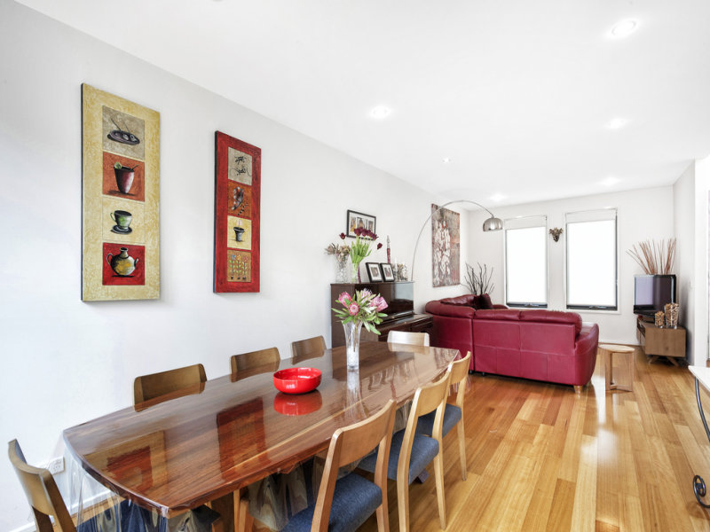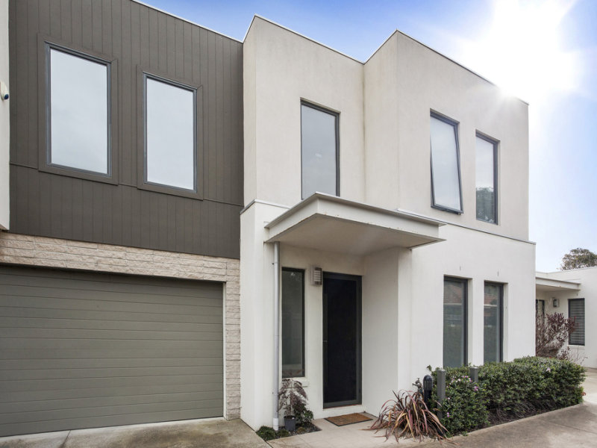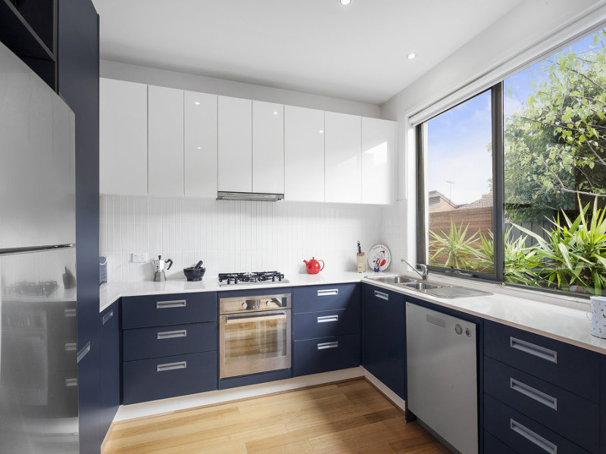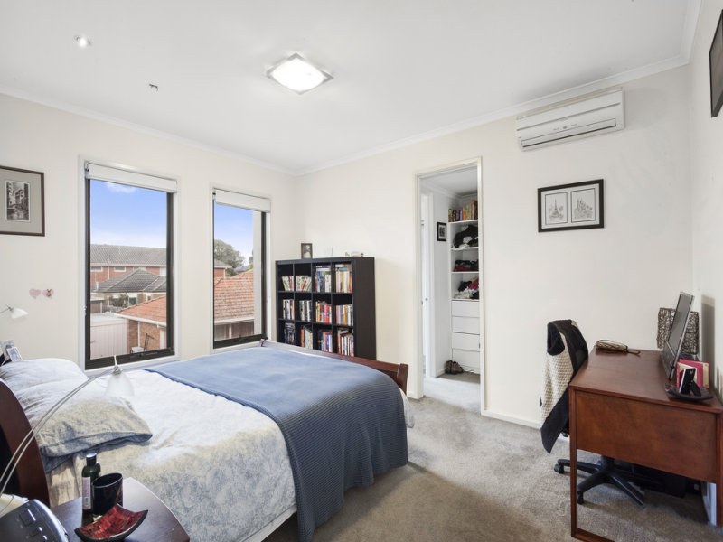Downstairs  
  - Open plan living and dining area  
  - Fully appointed kitchen with ample storage space  
  - Electric oven  
  - Dishwasher  
  - Vanity  
  - Courtyard Decking, perfect for Entertaining with low maintenance Garden and Double Glass doors to BBQ area  
  - Double lockup Remote Garage  
    
  Upstairs  
  - Family room/study/home office  
  - Master bedroom with walk in robe and ensuite  
  - Further two double bedrooms both built in robes   
  - Central bathroom with walk in shower, Bath, Toilet and Laundry  
    
  Features:  
  - R/C heating and cooling (in living room and all bedroom)  
  - Lockup Electric Security Gates  
  - Storage Throughout  
  - Hardwood Floors  
  - Natural Lighting Throughout  
  - Intercom
* $680 per week